PROJECT REPORT

1. INTRODUCTION:

1.1 Overview:

This project is about the 17th Lok Sabha election in the year of 2019. It was a qualitative analysis of the candidates in the Lok Sabha election.

1.2 Purpose:

The general election was held in India in seven phases 11 April to 19 May in 2019to elect the members of the 17th Lok Sabha. Votes were counted and the result was declared on 23 May. The election was resulted in a landslide victory of Bhartiya Janata party won 303 seats formed by the government. The BJP received 37.36% of the vote. The highest participation by the women voters.

2. PROBLEM DEFINITION & DESIGN THINKING:

2.1 Empathy Map:

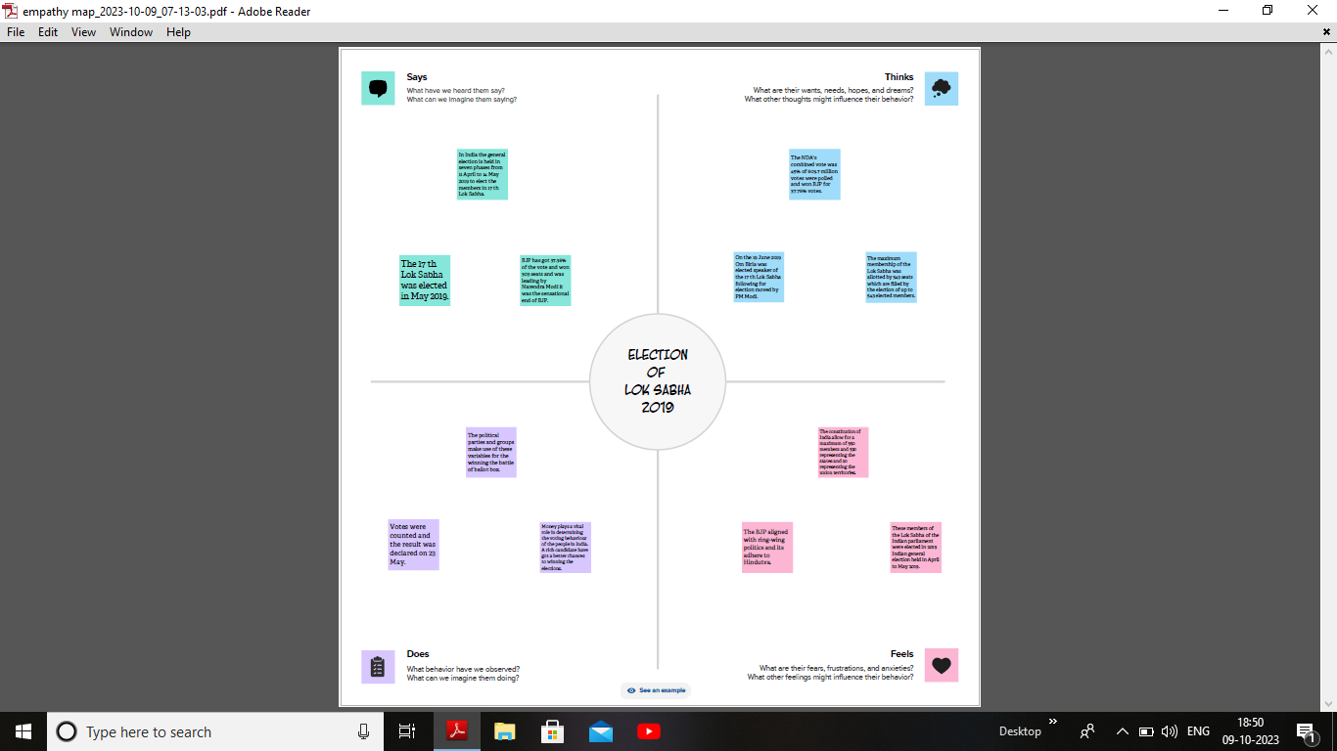

2.2 Ideation & Brainstorming Map:

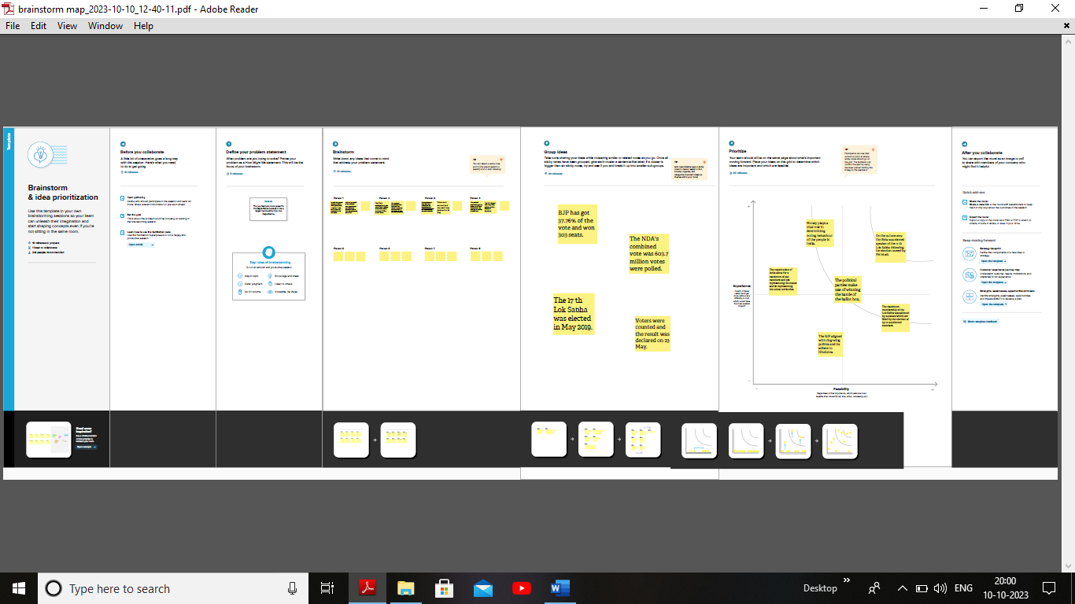

3. RESULT:

3.1 Dashboard:

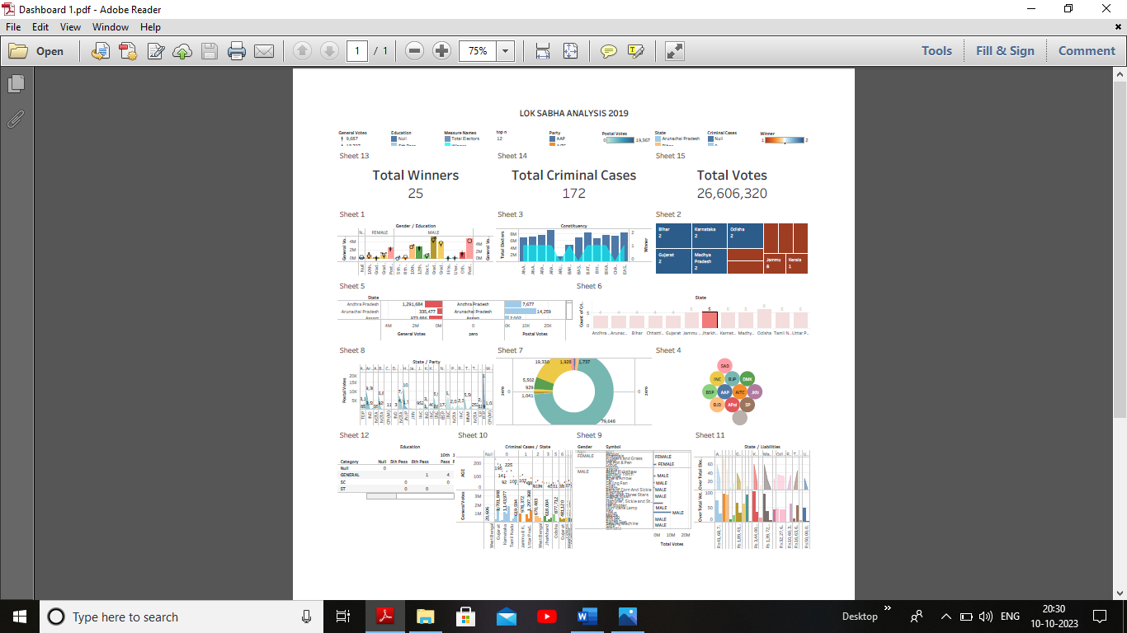

3.2 Story:

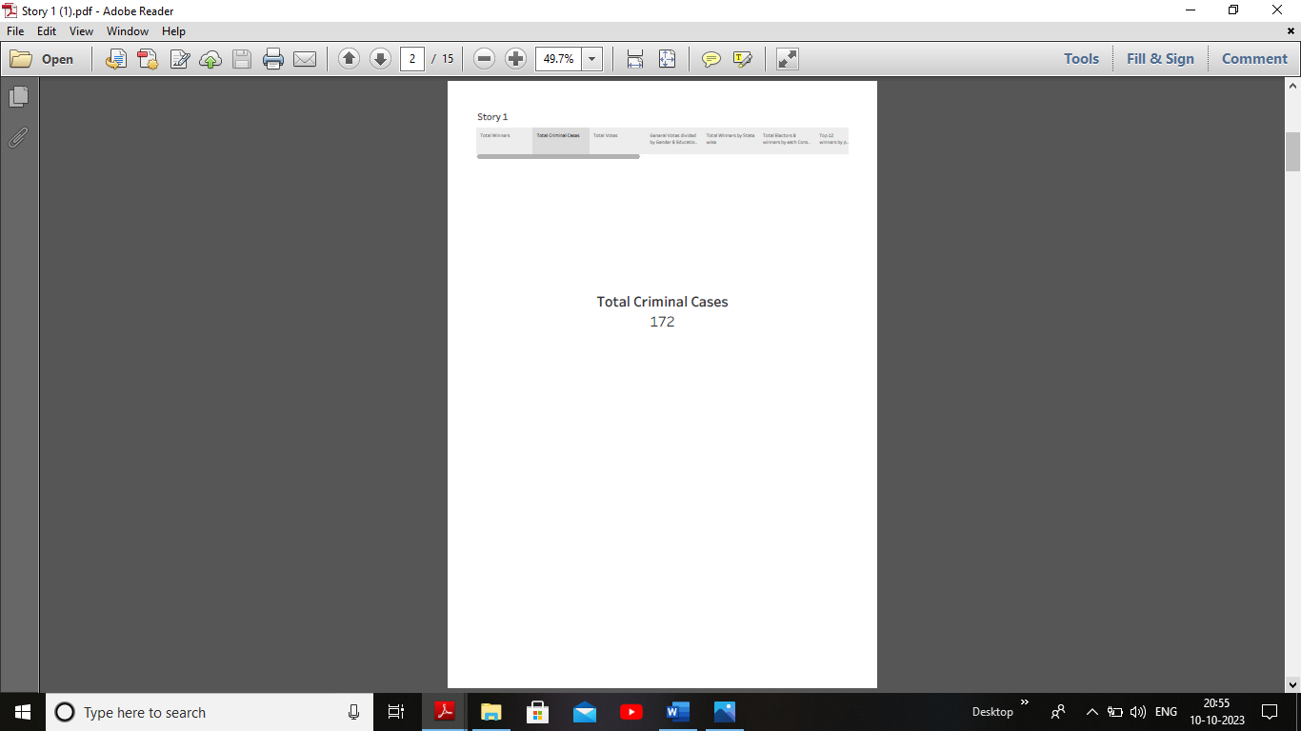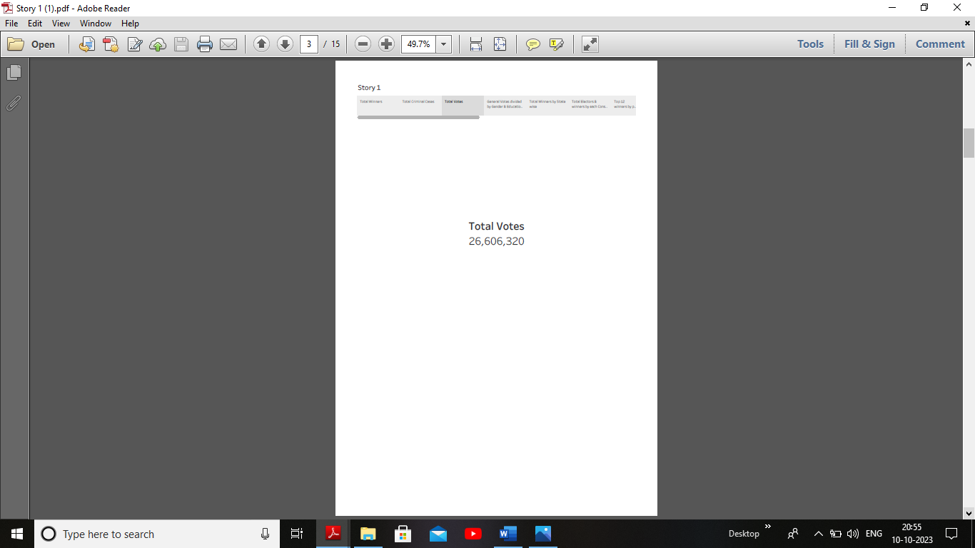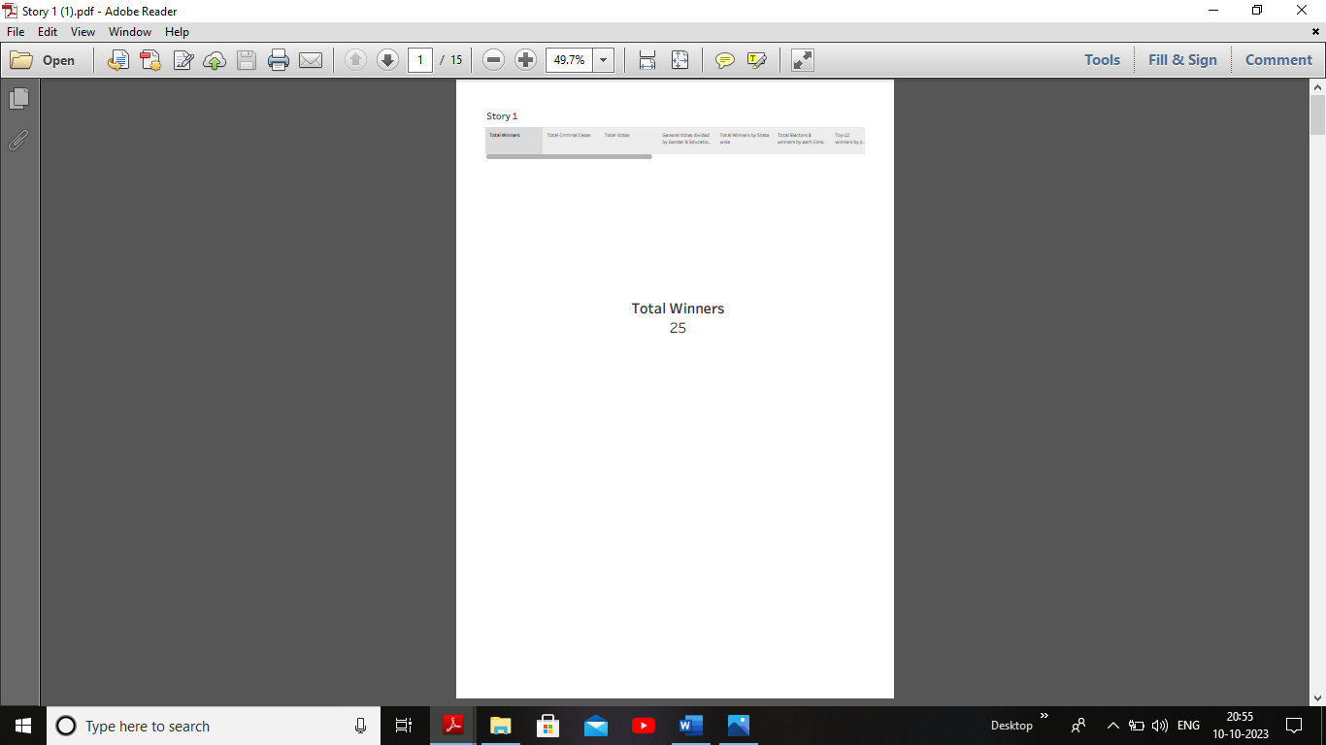

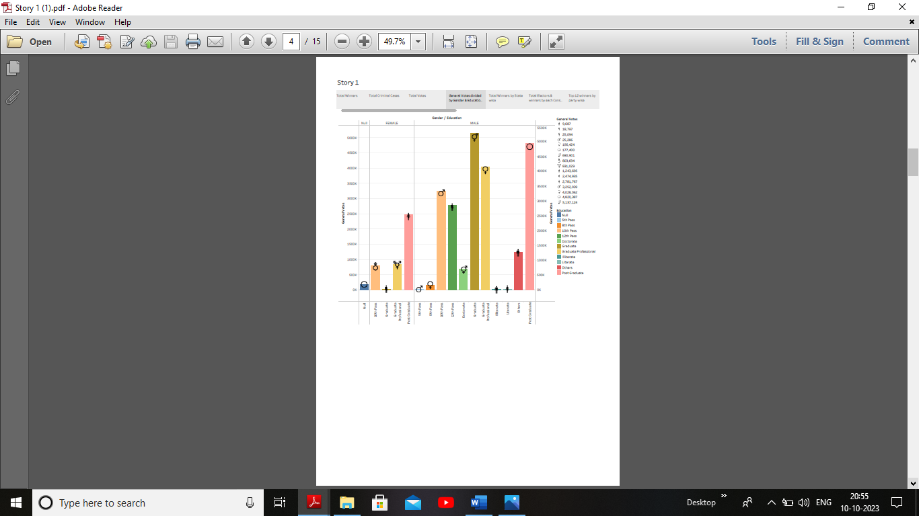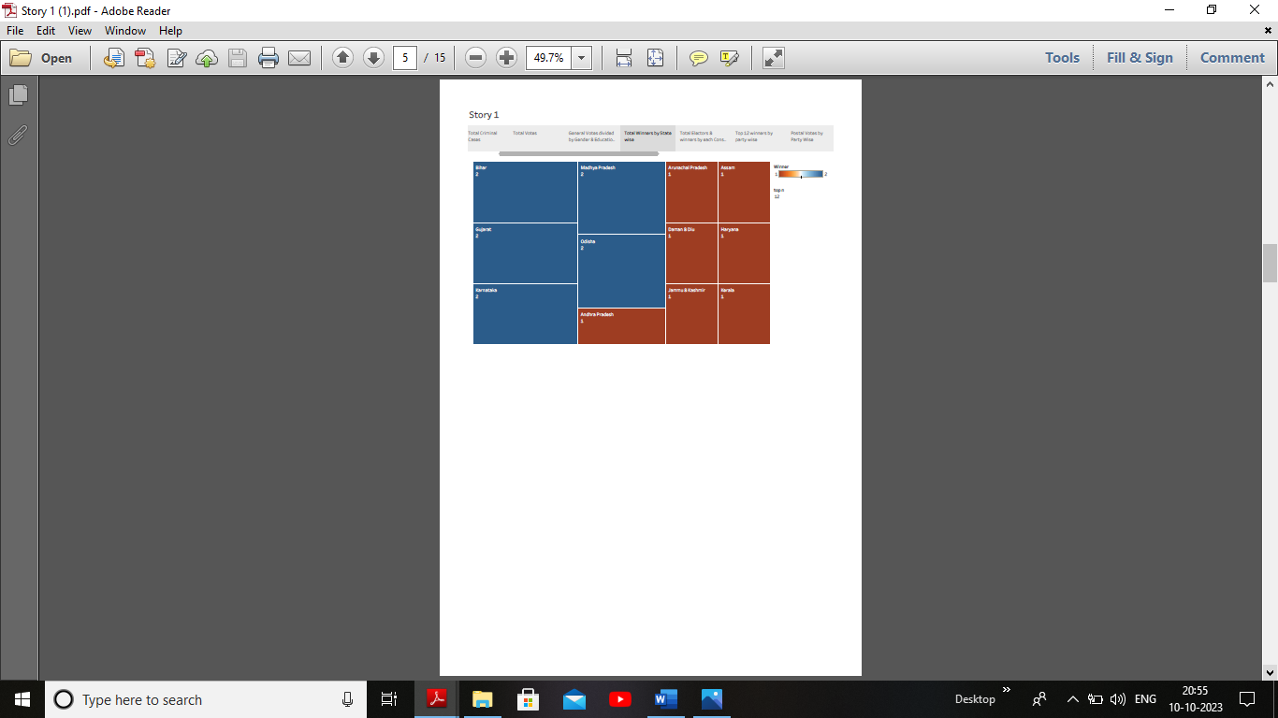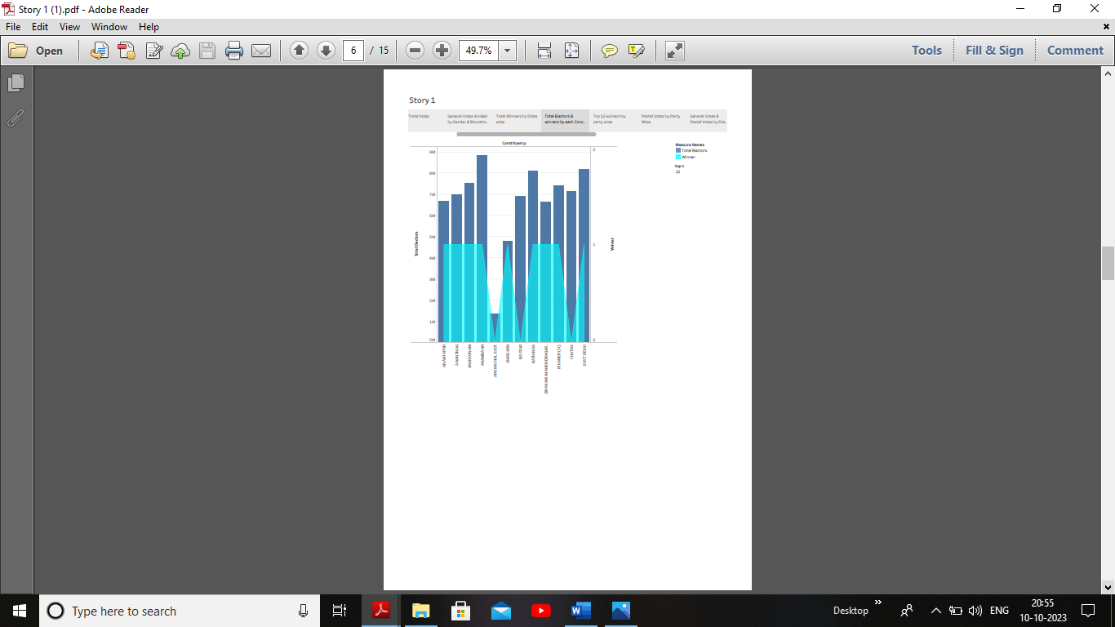

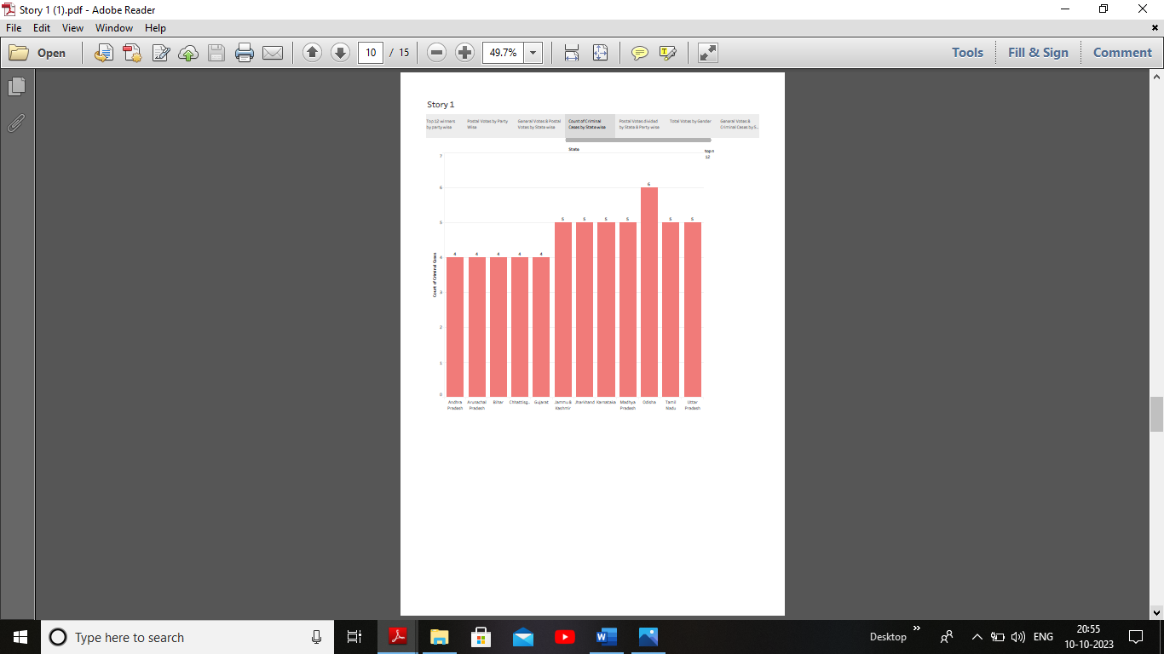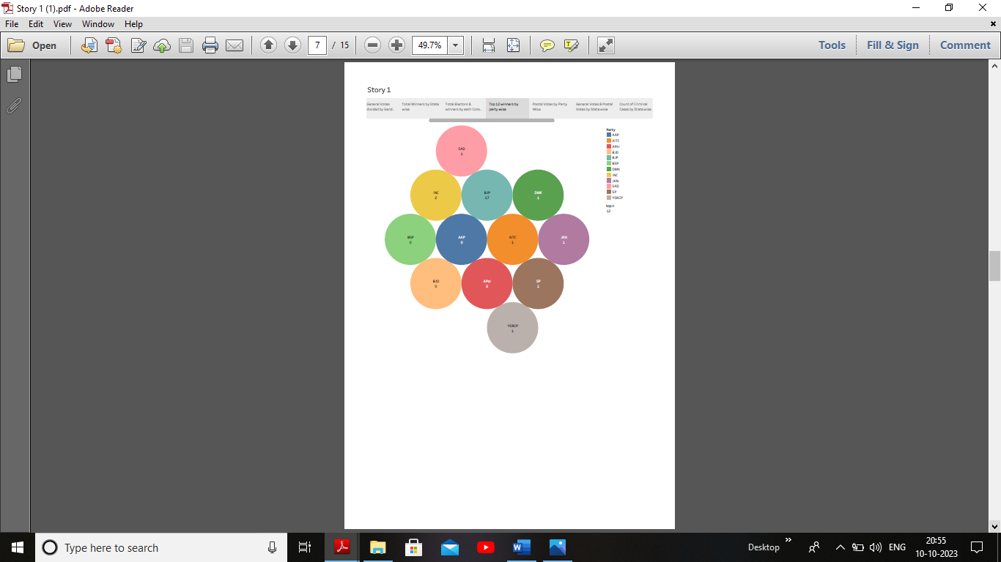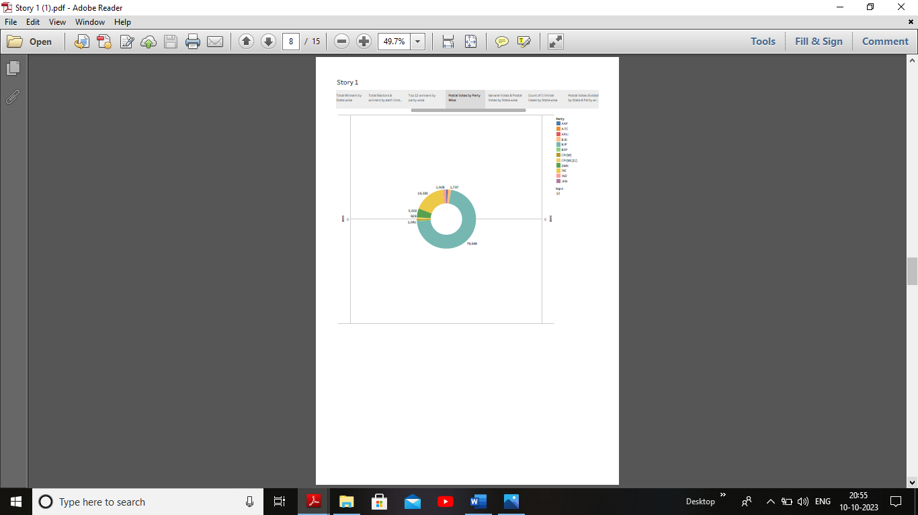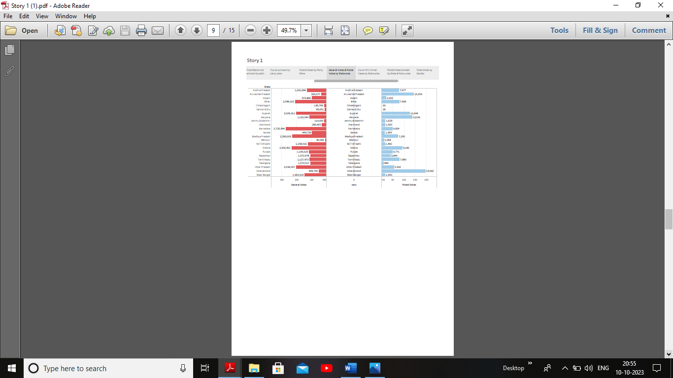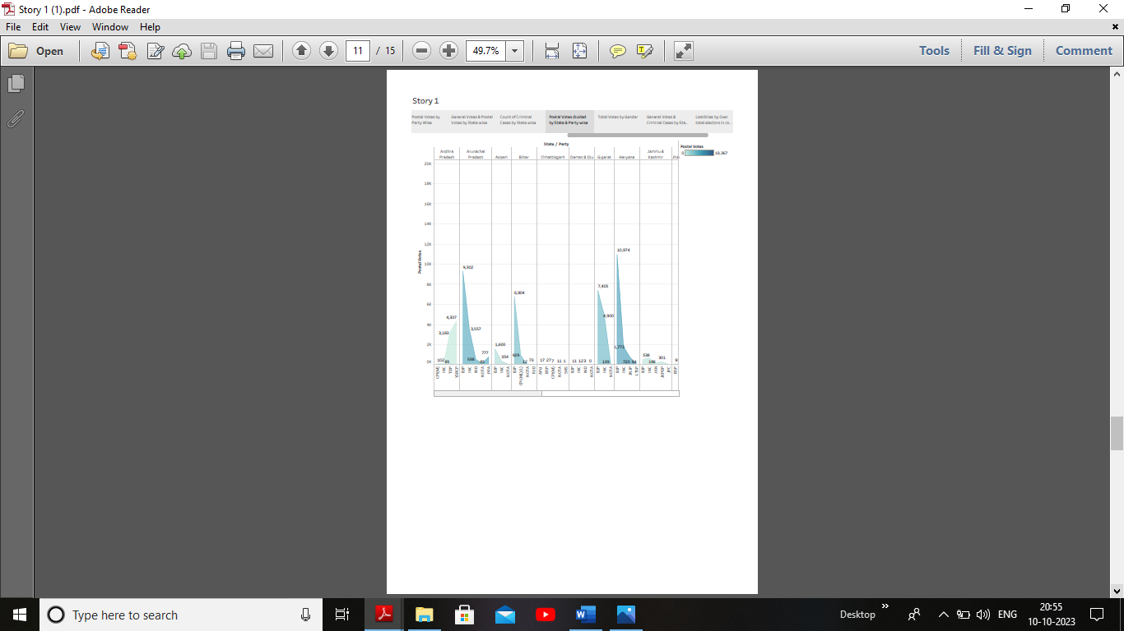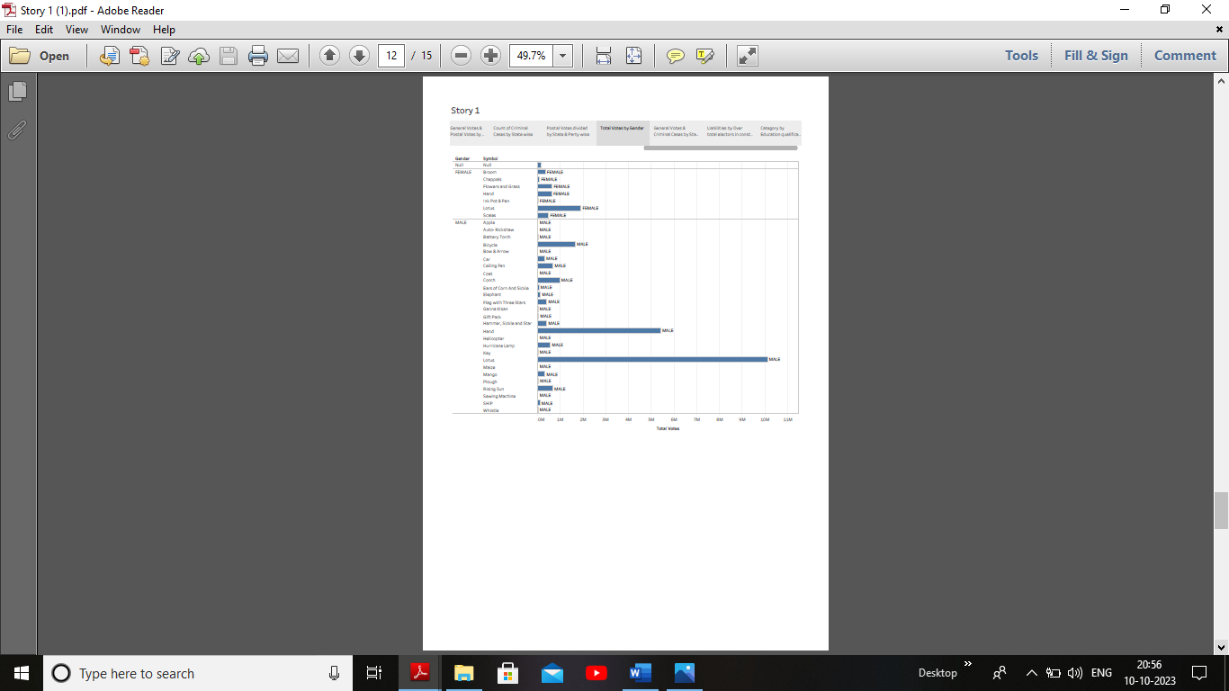

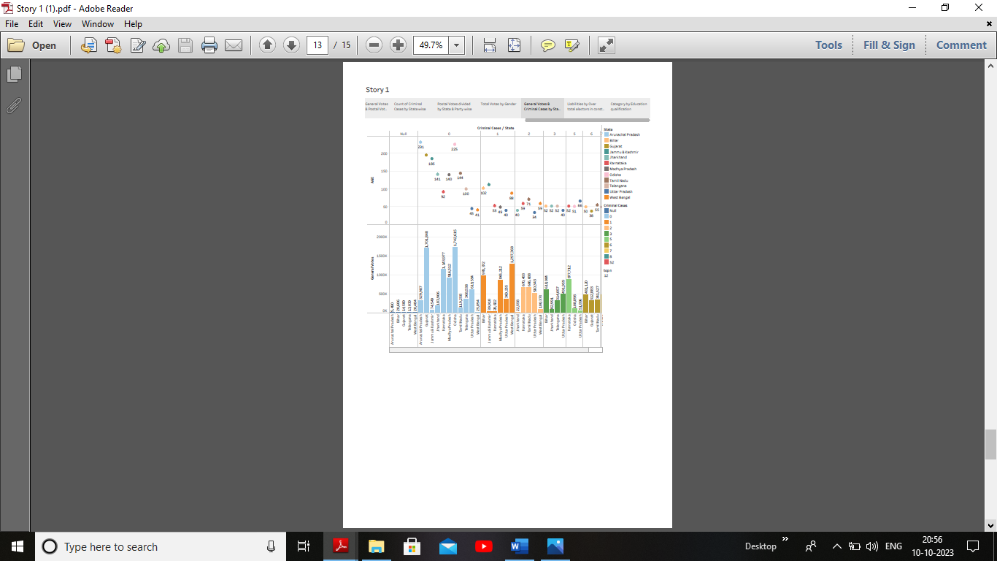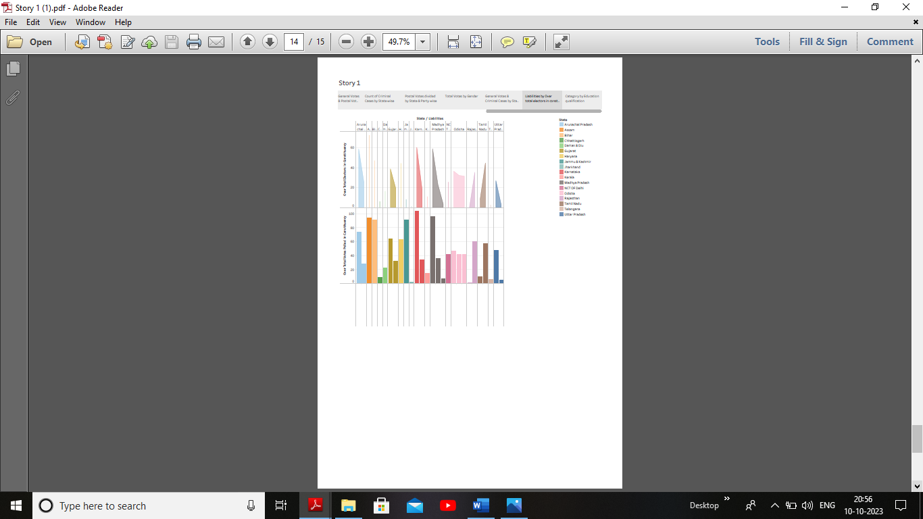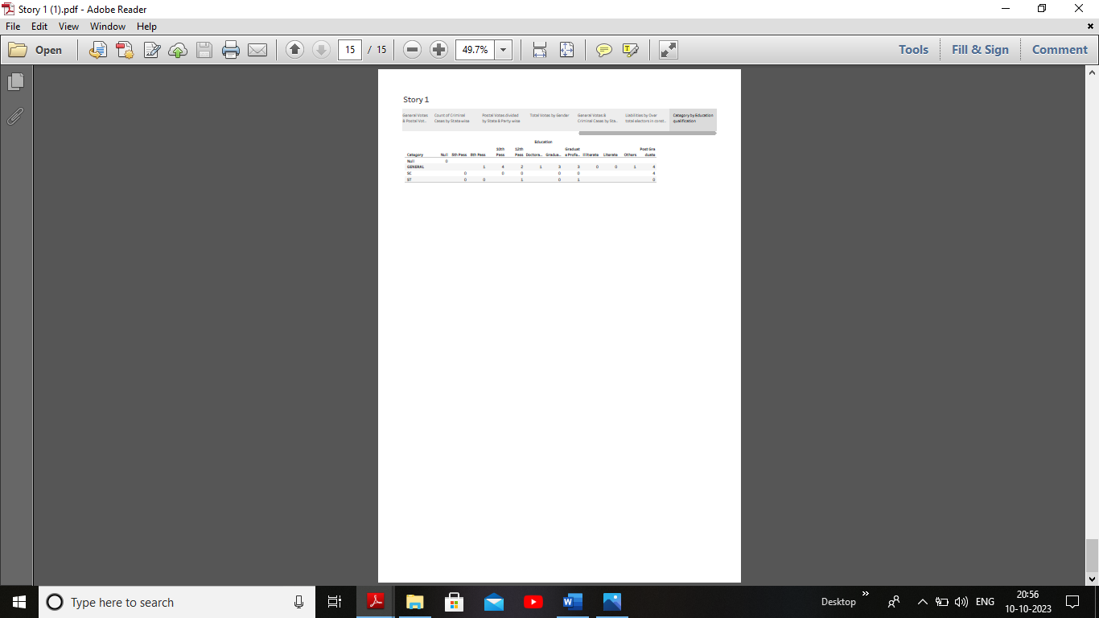

4.ADVANTAGES & DISADVANTAGES:

4.1 Advantages:

The Lok Sabha is the popular house. Its members are directly elected by the people. Another factor which makes the Lok Sabha more important than Rajya Sabha is cabinet responsibility. The members of the council of ministers at the centre are responsible to the Lok Sabha and not to the Rajya Sabha.

In India the money bill can be introduced only in the Lok Sabha; it cannot be introduced in the Rajya Sabha. The power of control over the finances by the Lok Sabha is powerful.

4.2 Disadvantages:

It helps in proper functioning of democracy through the system checks and balances. No confidence motion can only be introduced and passed in the Lok Sabha. So, it controls the despotism of the government. This can lead to reduced independent thinking and decision- making, as members might prioritize party interests over the interests of their constituents.

The prevalence of dynastic politics where family members of established politicians enter politics and secure positions in the Lok Sabha can hinder the emergence of new and diverse leadership potentially neglecting long term developmental and strategic decisions.

5. APPLICATIONS:

Data analytics can be applied in business in various ways. It can be used to analyze customer behaviour, optimize marketing campaigns, improve supply chain management, enhance product development, predict demand, identify fraud, optimize pricing strategies and improve overall business performance.

6. FUTURE SCOPE:

Data analytics and data analytics bootcamp is a huge industry and is predicted to keep growing. Data analytics courses are transforming business and reducing the time and cost invested in making quick decisions. Data analytics in India has a bright future due to several reasons. The widespread usage of big data assures a high level of employment, better wages and rising demand in future.

7. CONCLUSION:

From this we had to learnt about how the election was conducted in the Lok Sabha and to maintain the list of dataset and to create the empathy and brainstorm maps and also like the dashboard and story about the analysis of Lok Sabha.